**EXPERIMENT-17 VM**

HARDWARE COMPATIBILITY OF A VM

STEP -1: Create a new Virtual Machine

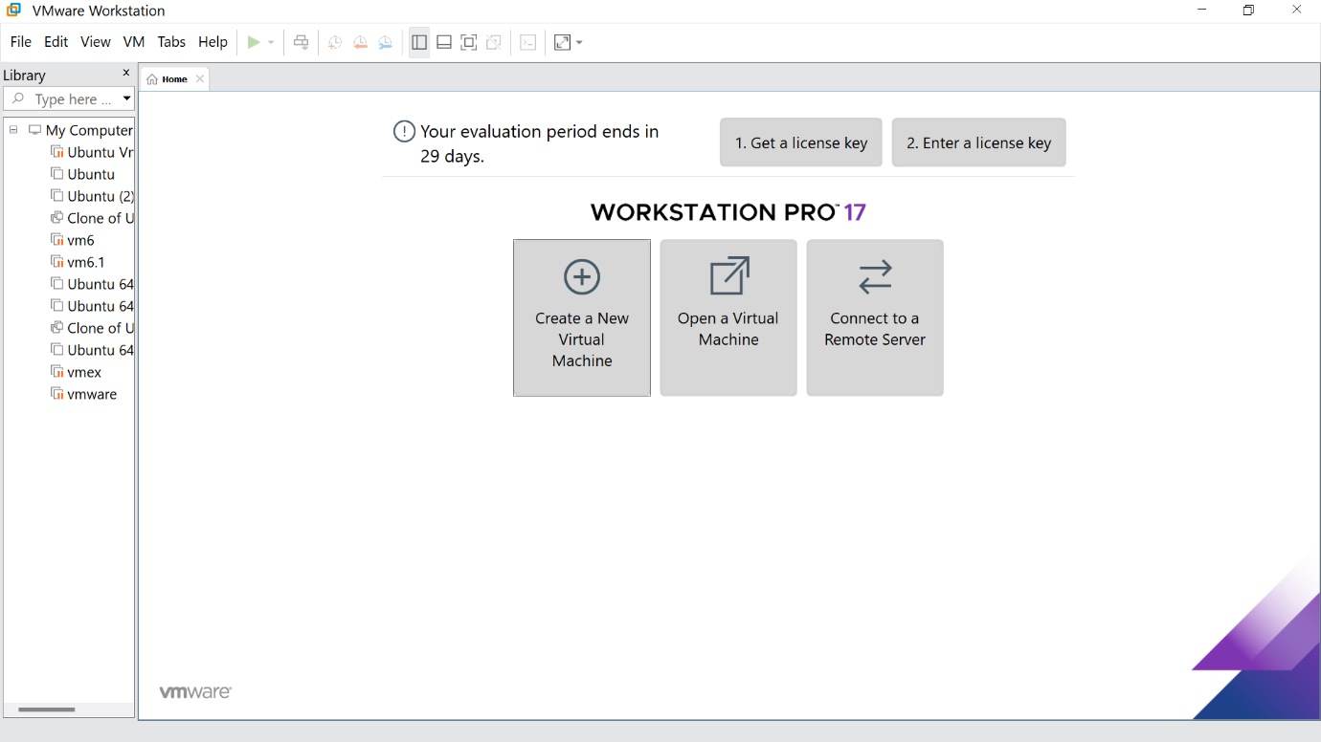

STEP -2: Click on Typical option and click Next

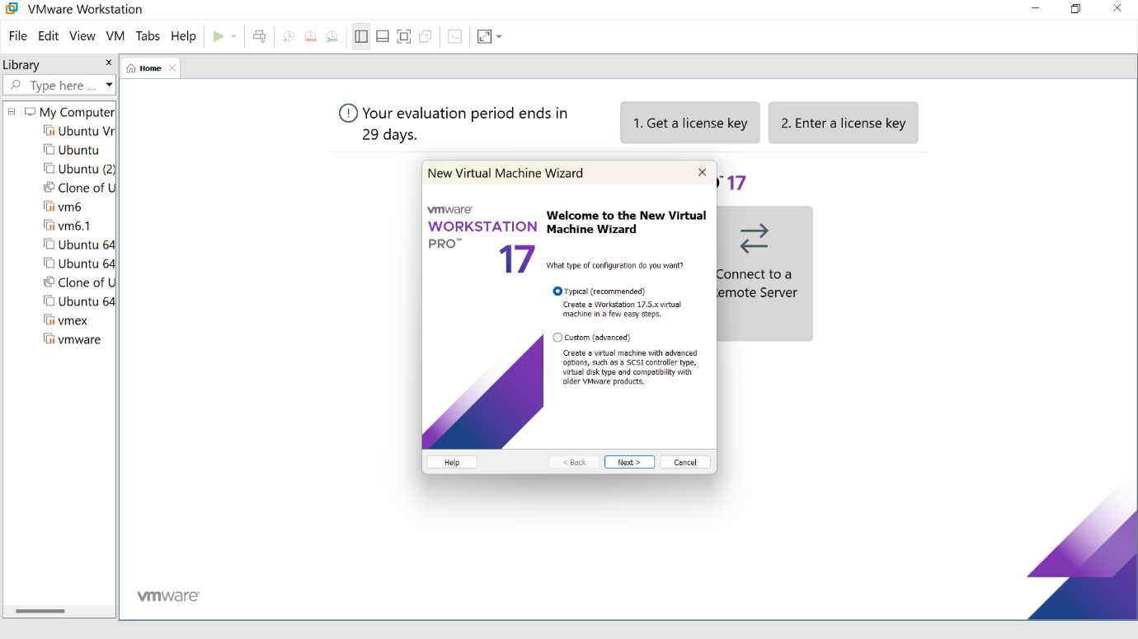

STEP -3: Click the install option and proceed to next step

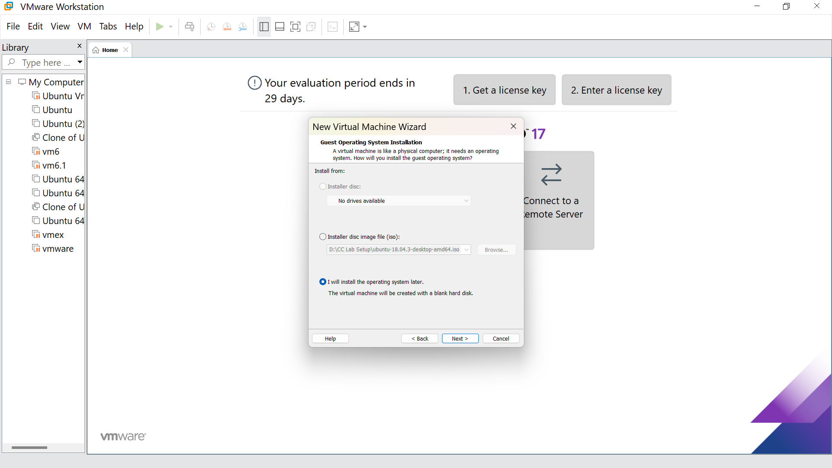

STEP -4: Select Linux option and click Next

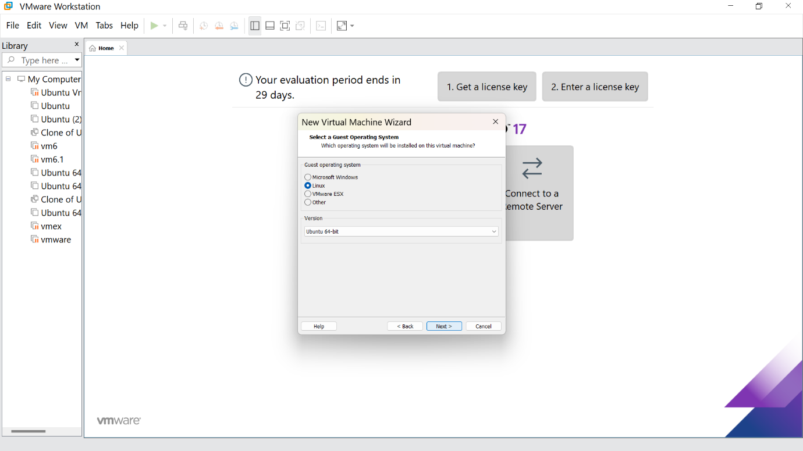

STEP -5: Give the name for the virtual machine(optional) and click next

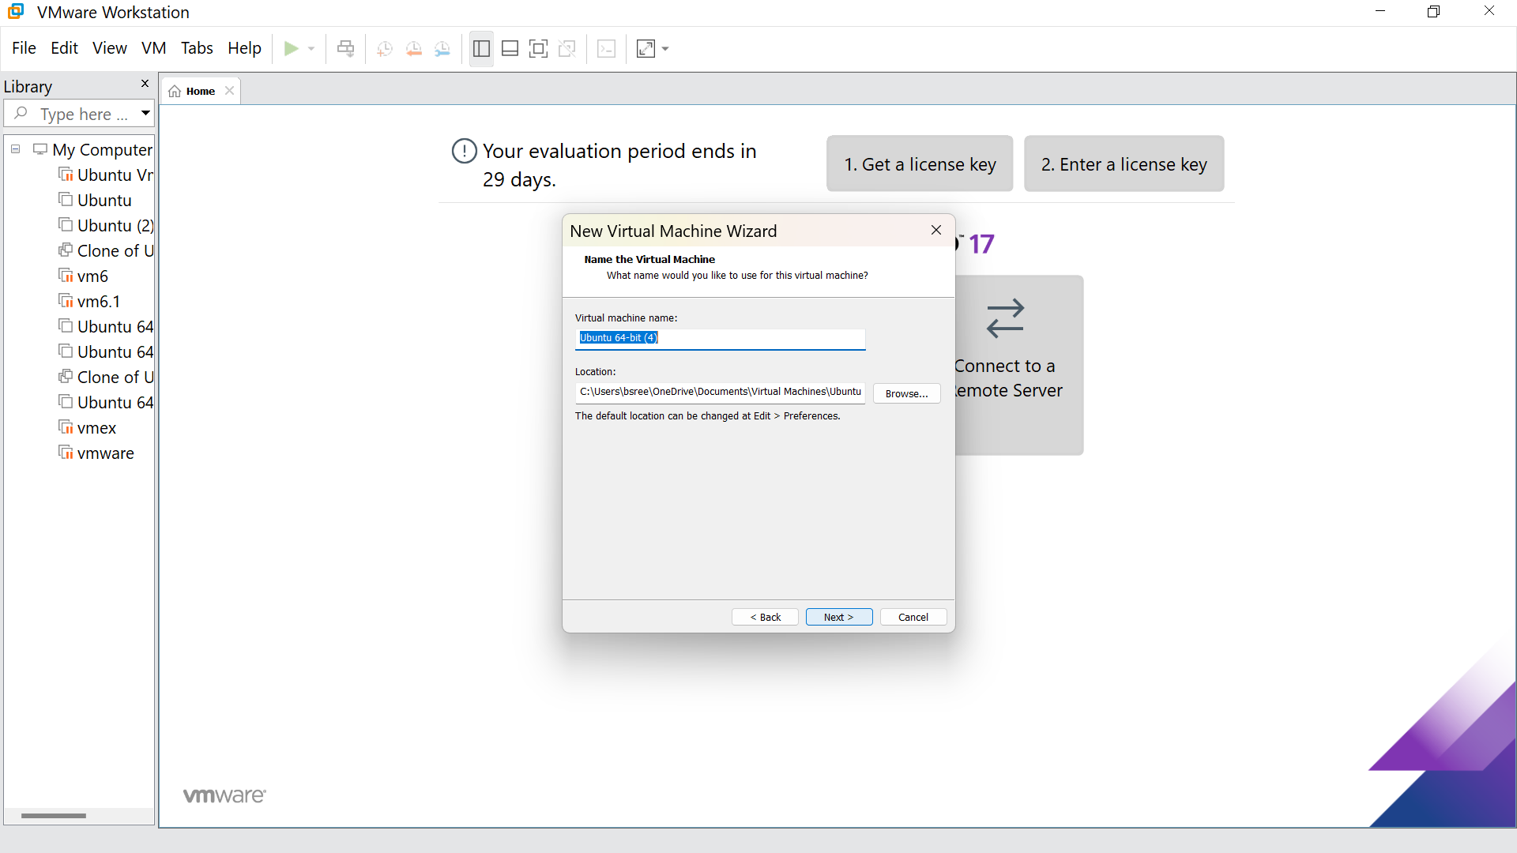

STEP -6: Select the option to store the disk in single file and click next

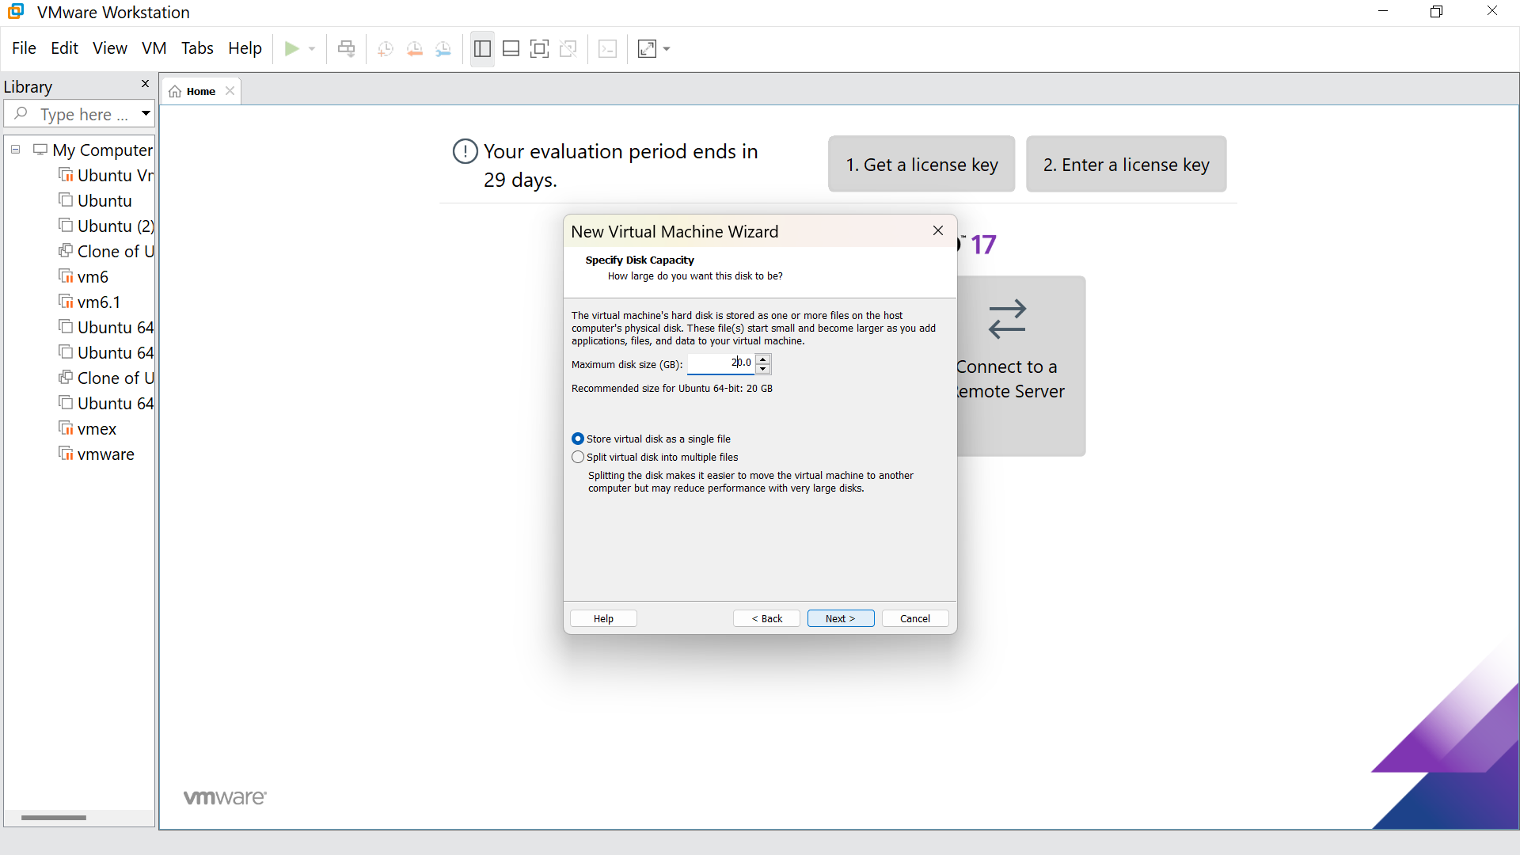

STEP -7: Our new VM is ready ,click finish

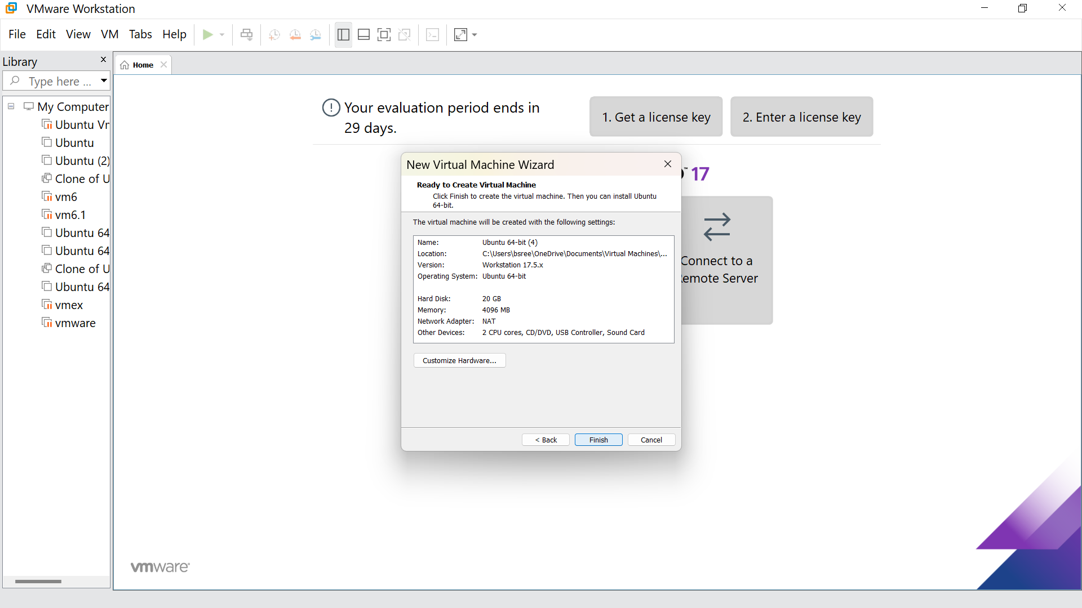

STEP -8: This is the creation of VM

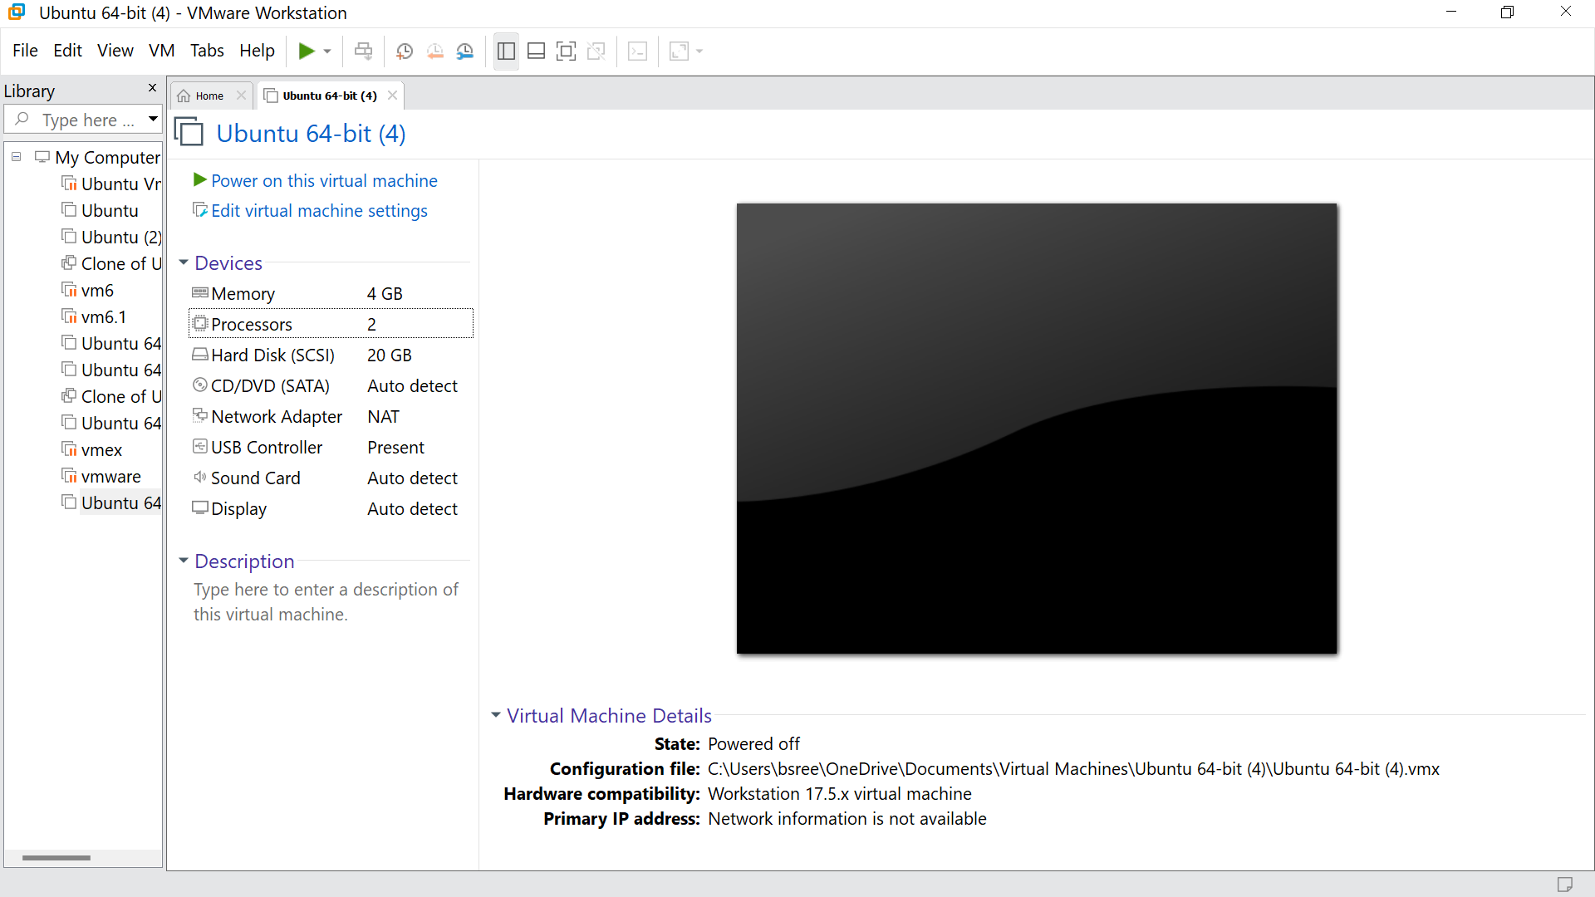

STEP -9: Go to the processors and give the number of processors as per your requirement, click ok

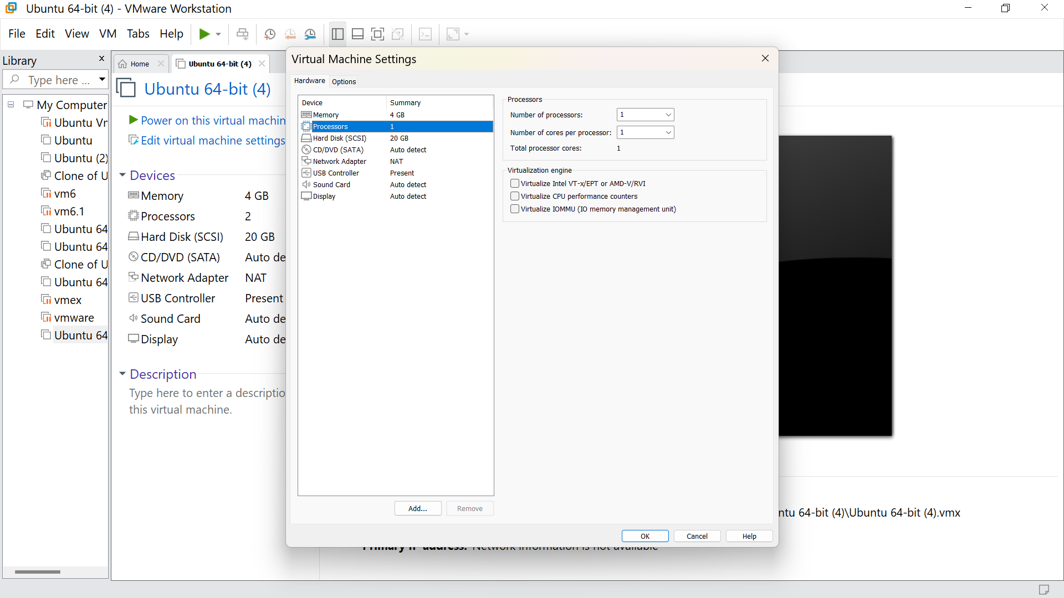

STEP -10: Hence we got the output

